21BDS0340

Abhinav Dinesh Srivatsa

Software Engineering Lab

Bug Tracker SRS Document

**Purpose**

To create a bug tracker application for organisations and teams to keep track of bugs and manage collaboration

**Scope**

**Objectives**

The primary objective of this project is to create an effective bug and issue tracker for organizational level software development. This project focuses on ease of creation of issues, having detailed teams and organizations for collaboration, and a seamless process to manage bug and issue history.

**Deliverables**

The main deliverables included in the bug tracking software are the following:

Profile

* Profile creating and updating
* Login with email and password and session management with a single access token
* Email verification

Organisation

* Organisation creating and updating
* Managing organisations

Teams

* Creating of dedicated teams
* Adding members to teams

Bugs

* Bugs creating and updating
* Adding status and priority to bugs
* Assigning teams for bugs
* Maintaining a details bug and issue history

UI/UX

* Detailed bug and issue views
* A clean and concise interface to create organizational structures

Miscellaneous

* Detailed email views for team members when bugs and issues are created by the quality assurance team

**Project Exclusions**

This project will receive no updates to functionality and the user interface. The project will also not be hosted online. All testing will be done locally.

**User Classes**

|  |  |
| --- | --- |
| Class | Description |
| Organisation Owner | Has permissions to create and assign members to teams in their organisation. They also gain a view to manage their organisation. They also have every permission a team member has in any team. |
| Team Member | Has permissions to create bugs and maintain them. |

**Operating Environment**

The expected operating environment for this application is in any modern browser versions. This application is not meant to be optimized for mobile view.

**Constraints**

The constraints for this project are listed below:

* Estimated time to complete project is 10 weeks
* Estimated budget is 0 (no budget constraint)
* Estimated workers is 1
* Customer satisfaction and revisions of user interface and functionality

**Assumptions**

The organizational hierarchical structure and the team interface are assumed to be split properly between developers, product specifiers, and quality assurance. These team members may be named otherwise, but the assumption is that one profile may not be a part of two different teams.

Another assumption is that only a single profile may control an organisation, this sole person has the power to create teams, and dissolve the organisation. This role can be transferred to another profile at any point, transferring the ownership and authority to them.

**Dependencies**

This project has no dependencies, all development and requirements is independent and new

**Business Rules and Functional Requirements**

**Profile**

|  |  |  |
| --- | --- | --- |
| Attribute | Constraints | Changeability by user interface |
| ID | Unique, UUID v7, mandatory | No |
| Name | Mandatory, lower-case letters and numbers only, 20 characters max | Yes |
| Email | Unique, mandatory | Yes, but requires verification |
| Password | Mandatory, 1 lower, 1 upper, 1 number, 1 special, between 8-20 characters | Yes, but requires confirmation |
| Created At | Mandatory | No |
| Modified At | Mandatory | No |

1. A profile cannot be deleted
2. A profile can be modified at any time
3. Email verification needs to be done before a profile can access anything in the bug tracker application
   1. Email verification can be done by sending an email to the profiles email address and verifying a link
4. Each profile may have one organisation

**Organisation**

|  |  |  |
| --- | --- | --- |
| Attribute | Constraints | Changeability by user interface |
| ID | Unique, UUID v7, mandatory | No |
| Name | Mandatory, alphabets, numbers, spaces and any of the following special characters: !@#$%^&*(),_.?, 20 characters max | Yes, only by owner |
| Description | Unique, alphabets, numbers, spaces and any of the following special characters: !@#$%^&*(),_.?, mandatory | Yes, only by owner |
| Created At | Mandatory | No |
| Modified At | Mandatory | No |

1. An organisation must be created by a profile
2. An organisation cannot be deleted, but can be transferred to another profile
3. An organisations name and description can be updated at any time by its owner
4. Each organisation can have a maximum of 10 teams

**Team**

|  |  |  |
| --- | --- | --- |
| Attribute | Constraints | Changeability by user interface |
| ID | Unique, UUID v7, mandatory | No |
| Name | Mandatory, alphabets, numbers, spaces and any of the following special characters: !@#$%^&*(),_.?, 20 characters max | Yes, only by owner |
| Description | Unique, alphabets, numbers, spaces and any of the following special characters: !@#$%^&*(),_.?, mandatory | Yes, only by owner |
| Created At | Mandatory | No |
| Modified At | Mandatory | No |

1. A team must be created by an organisations owner
2. A team cannot be deleted
3. An teams name and description can be updated at any time by its organisations owner
4. Multiple teams can have the same profile

**Bug**

|  |  |  |
| --- | --- | --- |
| Attribute | Constraints | Changeability by user interface |
| ID | Unique, UUID v7, mandatory | No |
| Name | Mandatory, alphabets, numbers, spaces and any of the following special characters: !@#$%^&*(),_.?, 20 characters max | Yes, only by owner team |
| Description | Unique, alphabets, numbers, spaces and any of the following special characters: !@#$%^&*(),_.?, mandatory | Yes, only by owner team |
| Status | Mandatory, one of: open, closed, cancelled | Yes, only by owner team and assigned to team |
| Priority | Mandatory, one of: 5, 4, 3, 2, 1 | Yes, only by owner team |
| Assigned To | Mandatory team | Yes, only by owner team and assigned to team |
| Assigned By | Mandatory profile | No |
| Closed By | Mandatory profile | No |
| Created At | Mandatory | No |
| Modified At | Mandatory | No |
| Closed At |  | No |

1. A bug must be created by a profile part of a team in an organisation
2. All members in the assigned to team must be emailed of the bug

**Use Cases**

**Profile Creation**

A new user creates a profile

|  |  |
| --- | --- |
| Actor Actions | System Response |
| Actor signs up using email, name and password | An auto generated email is sent to the email address |
| Actor clicks on the link to verify themselves | The actor is now verified, and can now log in |
| Actor goes to the login page and enters their email and password | The actor is now signed in, and can access services using an access token handled by the application |

**Organisation and Team Creation**

A profile creates a new organisation

|  |  |
| --- | --- |
| Actor Actions | System Response |
| Actor clicks on a button to create a new organisation | The actor is redirected to the appropriate organisation creation page |
| Actor fills in the name and description | The actor now owns an organisation if none were owned before |
| Actor clicks on the button to create a new team | The actor is redirected to the appropriate teams creation page |
| Actor clicks on a button to create a new team | The organisation now owns a team |

**Team Profile Addition**

A profile adds another profile to their organisations team

|  |  |
| --- | --- |
| Actor Actions | System Response |
| Actor clicks on a button to add a team member | The actor is redirected to the appropriate team member addition page |
| Actor fills in the email | An email is sent to the profile to be added to the team |
| Actor 2 clicks on the link | The actor 2 is now part of actor 1’s organisation and part of the particular team |

**Bug Creation**

A bug is created by a team member

|  |  |
| --- | --- |
| Actor Actions | System Response |
| Actor clicks on a button to create a bug | The actor is redirected to the appropriate bug creation page |
| Actor fills in the details and the assigned to field is another team | An email is sent to all the members in the assigned to team and a bug is created |

**Bug Resolution**

A bug is resolved by an assigned team member

|  |  |
| --- | --- |
| Actor Actions | System Response |
| Actor clicks on a bug to resolve it | The bug is now marked as resolved |

**Data Requirements**

**ER Diagram**

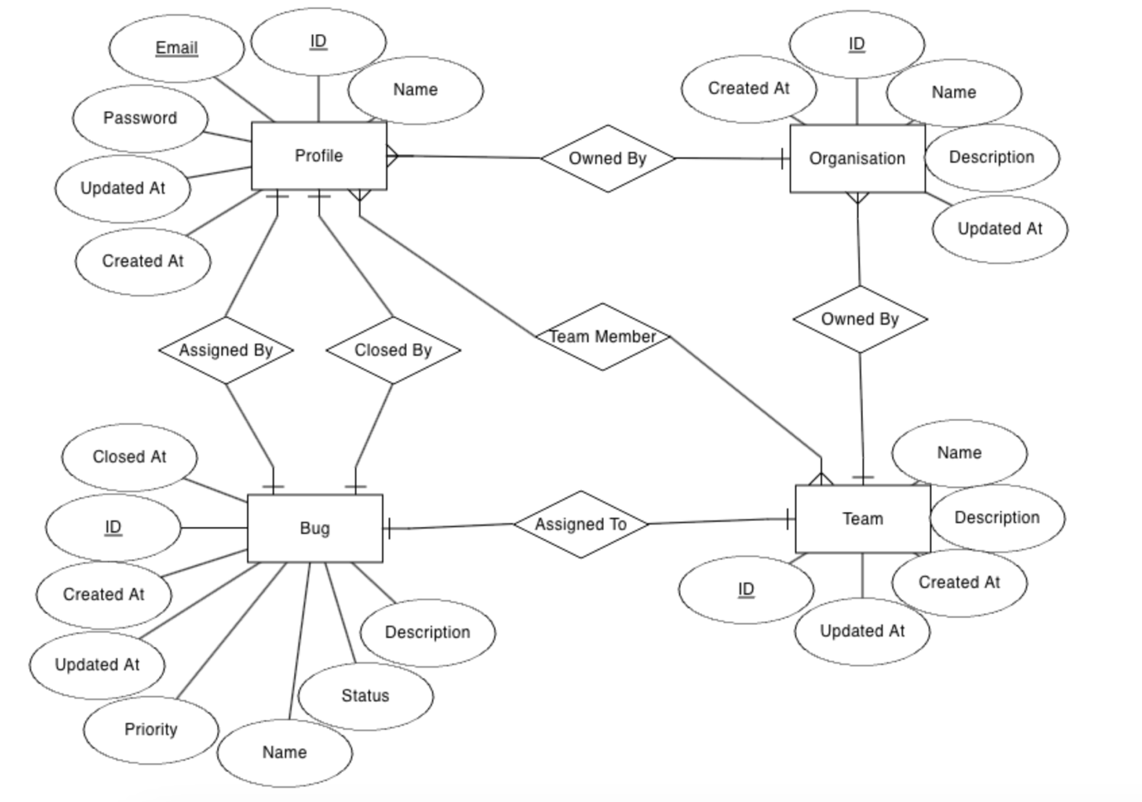

**Data Dictionary**

|  |  |  |  |  |  |
| --- | --- | --- | --- | --- | --- |
| Attribute | Entity | Required | Type | Length | Comments |
| ID | Profile | Yes | UUID | 36 |  |
| Name | Profile | Yes | Text | 20 | Lower case and numbers only |
| Email | Profile | Yes | Text |  | Email type |
| Password | Profile | Yes | Text |  | Hashed password |
| Created At | Profile | Yes | Time |  | Time when profile was created |
| Modified At | Profile | Yes | Time |  | Time when profile was last modified |
| ID | Organisation | Yes | UUID | 36 |  |
| Name | Organisation | Yes | Text | 20 | Alphabets, numbers, spaces and any of the following special characters: !@#$%^&*(),_.? |
| Description | Organisation | Yes | Text | 200 | Alphabets, numbers, spaces and any of the following special characters: !@#$%^&*(),_.? |
| Owner | Organisation | Yes | UUID | 36 | Reference: Profile |
| Created At | Organisation | Yes | Time |  |  |
| Modified At | Organisation | Yes | Time |  |  |
| ID | Team | Yes | UUID | 36 |  |
| Name | Team | Yes | Text | 20 | Alphabets, numbers, spaces and any of the following special characters: !@#$%^&*(),_.? |
| Description | Team | Yes | Text | 100 | alphabets, numbers, spaces and any of the following special characters: !@#$%^&*(),_.? |
| Organisation | Team | Yes | UUID | 36 | Reference: Organisation |
| Created At | Team | Yes | Time |  |  |
| Modified At | Team | Yes | Time |  |  |
| Team | Team Member | Yes | UUID | 36 | Reference: Team |
| Profile | Team Member | Yes | UUID | 36 | Reference: Profile |
| Created At | Team Member | Yes | Time |  |  |
| Modified At | Team Member | Yes | Time |  |  |
| Name | Bug | Yes | Text | 20 | Alphabets, numbers, spaces and any of the following special characters: !@#$%^&*(),_.? |
| Description | Bug | Yes | Text | 100 | Alphabets, numbers, spaces and any of the following special characters: !@#$%^&*(),_.? |
| Status | Bug | Yes | Enum |  | One of: open, closed, cancelled |
| Priority | Bug | Yes | Enum |  | One of: 5, 4, 3, 2, 1 |
| Assigned To | Bug | Yes | UUID |  | Reference: Team |
| Assigned By | Bug | Yes | UUID |  | Reference: Profile |
| Closed By | Bug | No | UUID |  | Reference: Profile |
| Created At | Bug | Yes | Time |  |  |
| Modified At | Bug | Yes | Time |  |  |
| Closed At | Bug | No | Time |  |  |

**Data Maintenance**

1. The application must retain bugs from all time
2. The application must not lose any data at all, no data deletions will be performed
3. Data warehousing can happen after a 5 year period of bugs

**External Requirements**

No external requirements are present for this project. This project has no dependencies to delay or wait for.

**Non-Functional Requirements**

1. The application and the backend must be online 99.99% of the time excluding maintenance breaks
2. The backend system must be containerised to run on any machine with containerd or Docker
3. The system must only have updates in off hours to maintain availability
4. The system must be deployed using the blue/green method to prevent crashes and to have safe rollbacks
5. The system must have automatic scaling based on user and network demand
6. The system must always show timestamps in the local time zone

**Appendix**

**Task List**

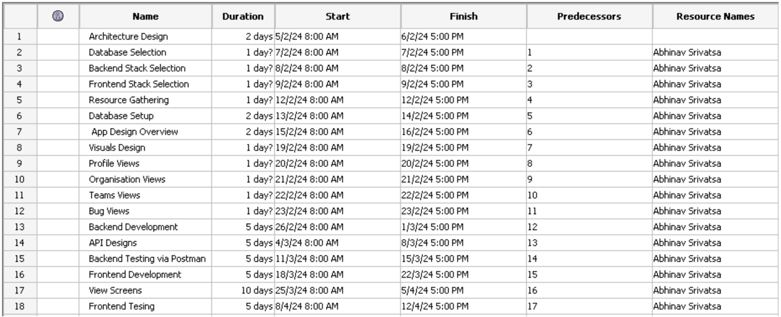

**Gantt Chart**

